**24 Januari 2022**

zabbix installation

-- server ubuntu 20.04 LTS

-- PC / Host : i37100 , 8GB, 120 SSD

-- Zabbix 5.0 LTS

-- MySQL 8.0

-- IP : 172.16.9.250

-- user : root/4dm1nSYS

-- user : engineer/4dm1nSYS

[installation]

-- install zabbix repo to ubuntu

-- install zabbix from repo

-- apt install zabbix-server-mysql zabbix-web-mysql zabbix-apache-conf zabbix-agent

database mysql ex IRS

-- server/host : 172.16.1.116

-- reset root & irs user database

-- backup database

-- copy dump file to external storage

[database server ]

-- user : root/4dm1nSQL

-- user : zabbix/Z4bb!xs3rv3r

[create database]

mysql> create database zabbix character set utf8 collate utf8_bin

[create user database]

mysql> create user zabbix@localhost identified by ‘Z4bb!xs3rv3r’

mysql> grant all privileges on zabbix.* to zabbix@localhost

mysql> flush privileges

[installation]

-- base on official site : <https://www.zabbix.com/download?zabbix=5.0&os_distribution=ubuntu&os_version=20.04_focal&db=mysql&ws=apache>

--install zabbix-server done

[mikrotik ccr-1036 arkadia]

-- harus menambahkan rules pada firewall agar diperbolehkan akses port 161 snmp router

/ip firewall filter

add chain=input src-address=172.16.9.250 dst-port=161 action=accept

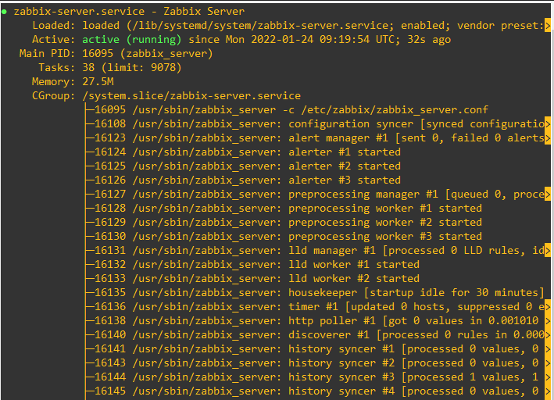

-- install mysql for data store( done )

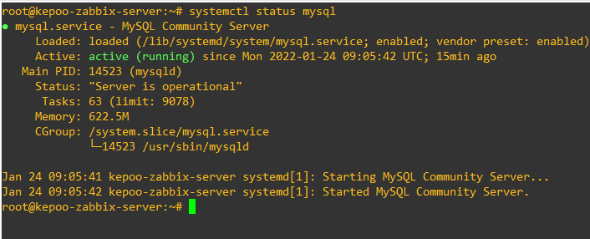

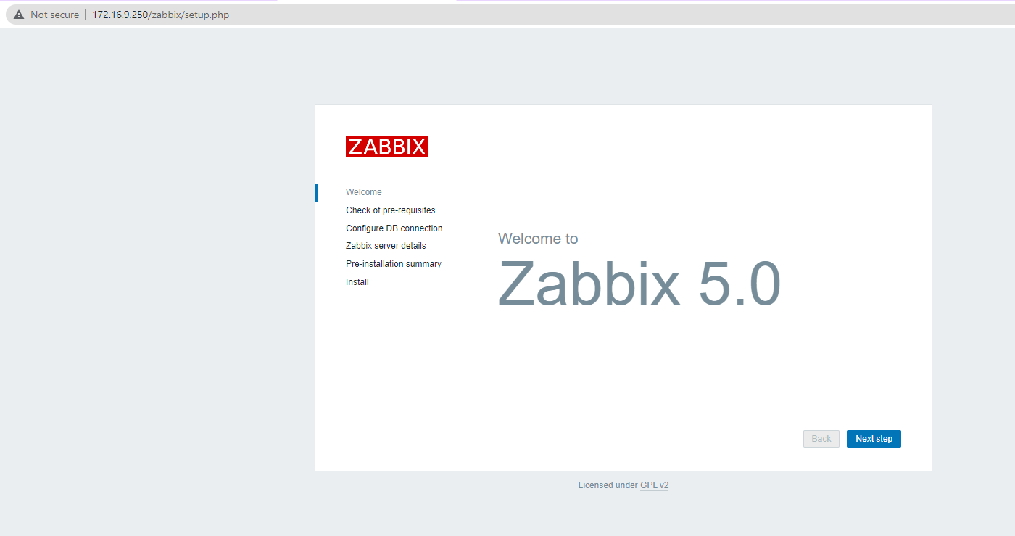

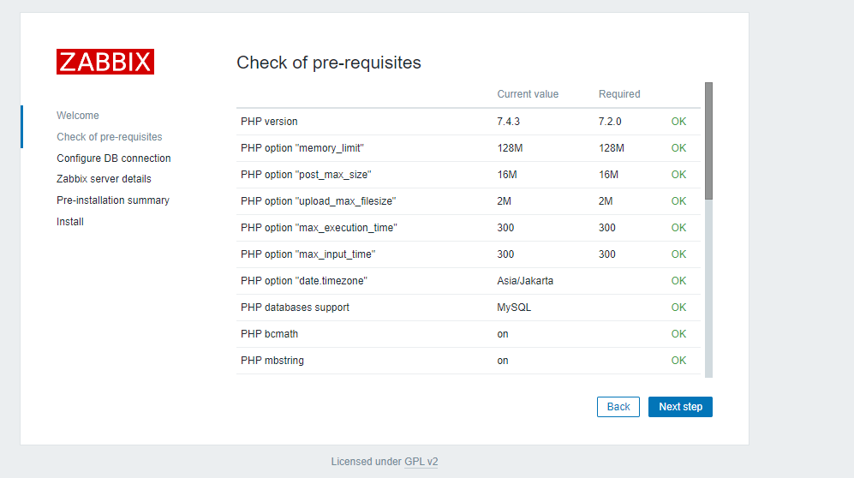

DB Connection Config

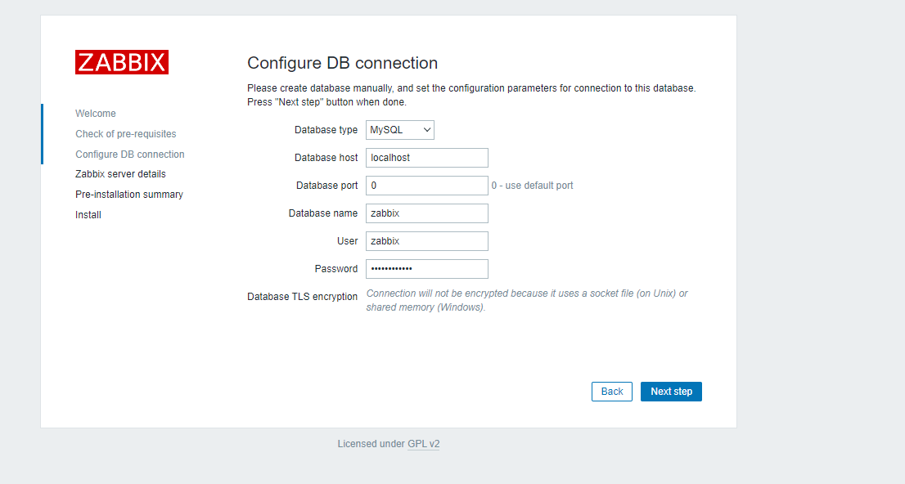

Setelah di allow 161 dari ip zabbix server :

karena ada rules di mikrotik arkadia, selain port yang di accept dari filter-rules. maka semua connection di reject/drop.

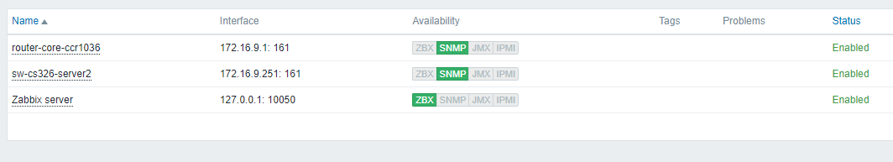

**Daily report 24 Januari 2022**

Maintenance DB MySQL ex server IRS

Reset password user database root, irs

Backup database schema avr

Move backup to external storage

IP forward/NAT

update port forward → Bumi <http://182.253.83.213:8007/> to [http://172.16.9.22:100](http://172.16.9.22:1003/)2

Setup PC/Host Zabbix server arkadia

Install on Ubuntu 20.04 LTS

MySQL 8.0

IP : 172.16.9.250